JSON Understanding document :

Link : <https://www.youtube.com/watch?v=U-5VHRvOFpA>

JSON Tutorial Part-5 | How To Read Data from JSON File in Java | JSON Simple API

1. How to edit value in existing JSON file

File file = **new** File(

"C:\\SAMA-MPP\\mppworkspace\\sama-mpp-api-tests-automation\\api-cucumber-mpp-poc\\src\\test\\resources\\com\\sama\\mpp\\cucumber\\input\\request_signature.json");

{

"proxy": {

"type": *"EMAIL"*,

"value": *"sambusdummy@rssting.com"*

},

"accountHolder": {

"person": {

"firstName": *"DeepaK"*,

"lastName": *"Mishra"*

}

},

"registerID": "123456",

"displayName": "SAMBUS Test12121",

"participantCode": "SABMUS",

"account": {

"name": *"Muscat Bank"*,

"type": *"BANKAC"*,

"value": *"SABMUS123456789"*

}

}

**try** {

FileReader fr = **new** FileReader(file);

JSONParser jsonparser = **new** JSONParser();

JSONObject jsonobject = (JSONObject)jsonparser.parse(fr);

jsonobject.put("registerID","123456"); // new value

jsonobject.put("displayName", "SAMBUS Test123"); // old value update for displayname

FileWriter fw = **new** FileWriter(file);

fw.write(jsonobject.toJSONString());

fw.flush();

fw.close();

// String str1 = (String)jsonobject.get("displayName");

// System.out.println( "updated displayName is "+str1);

// JSONObject participantCode = (JSONObject)jsonobject.get("displayName");

// System.out.println( " Proxy :: "+ participantCode);

} **catch** (IOException e) {

// **TODO** Auto-generated catch block

e.printStackTrace();

}

1. Rest Assured – PathParam Handling

In the below url,***{userid}*** is referred as path parameter.  
[http://localhost:/api/users/*{userid}*](http://localhost:/api/users/%7buserid%7d)

Response response = given()

.baseUri("https://localhost")

.basePath("api/users")

.pathParam("userid", 2)

.when()

.get("/{userid}");

Other method : We can also pass the path parameters without explicitly using ***pathParam()*** function.

int userid = 2;

Response response = given()

.baseUri("https://localhost")

.basePath("api/users")

.when()

.get("/{userid}",userid);

3.hha

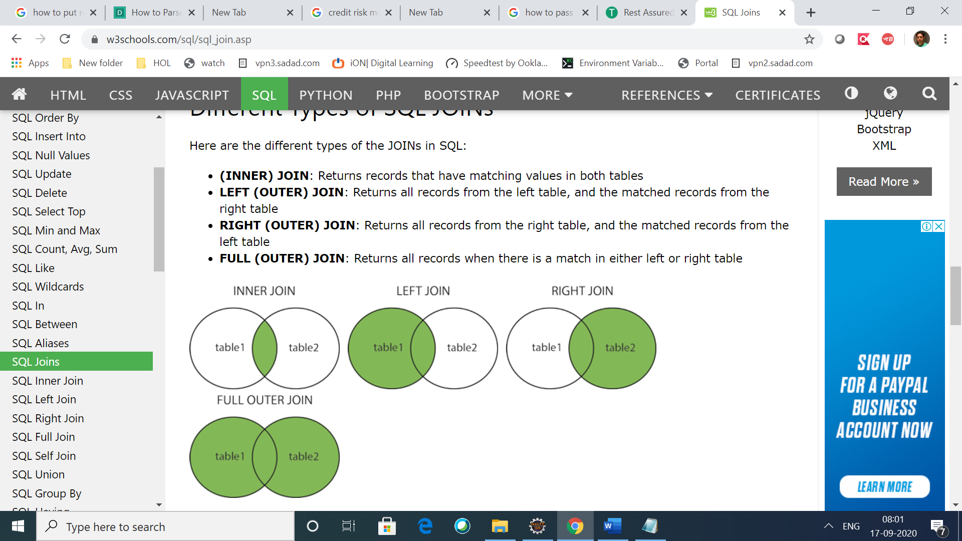

SELECT column_name(s)  
FROM table1  
FULL OUTER JOIN table2ON table1.column_name = table2.column_nameWHERE condition;